PRESERVING KERTAS TELO MANUSCRIPTS: CULTURAL HERITAGE CONSERVATION AT SONOBUDOYO MUSEUM, YOGYAKARTA

Author(s)

Abstract – Given its tropical location and rich historical legacy, Indonesia faces unique challenges in implementing museum collection preservation strategies. High humidity, erratic temperatures, light exposure, insects, and microbes all pose significant threats to Indonesian museum collections. Among the archive collections of the Sonobudoyo Museum in Yogyakarta is a material known as kertas telo (Javanese), also referred to as daluang/dluwang (bark cloth). Its use as an alternative writing medium became popular in the early 1900s amid the difficulties posed by the tropical climate, yet it has received little scholarly attention. While Indonesian traditional papermaking holds a distinctive place in the history of written media, research specifically addressing preventive conservation of kertas telo remains limited. This study examines three of seven kertas telo manuscripts in the Sonobudoyo Museum collection, tracing their history as an alternative to European paper and applying a nine-step standardized preventive conservation procedure. Employing a qualitative descriptive case study approach, data were collected through documentation, literature review, interviews, and observation. Findings show the museum's conservation methods are highly effective but require regular care and rigorous control against humidity, insect infestation, and light exposure. The study recommends stable storage conditions, proper handling, regular monitoring, pest control, and treatment scheduled according to each collection's specific damage condition. Given disparities in storage facilities, funding, and personnel expertise across Indonesian museums, sustained collaboration among museums, scholars, and government institutions is recommended to strengthen long-term conservation of kertas telo/dluwang as part of Indonesia's cultural heritage.

Keywords: Kertas telo; preventive conservation; manuscript preservation; tropical climate; museum collection

INTRODUCTION

Given that many museums now run preservation programs for their holdings, Indonesia, a tropical country with a rich historical legacy and artifacts, poses unique challenges. For Indonesian museum collections, extreme humidity, fluctuating temperatures, light exposure, and exposure to insects and microbes provide particular difficulties. The significance of preventive conservation measures, such as humidity control, temperature regulation, lighting management, and systematic collection maintenance, in minimizing the risk of deterioration and ensuring the long-term preservation of museum collections was highlighted in a comparable study conducted at Museum Geologi Bandung (Indriani, S.D., et.al., 2022). The combined effect of heat, humidity, and ultraviolet light fosters optimal circumstances for oxidation, mold proliferation, and insect infestation, rendering tropical surroundings unsuitable for museum and library conservation standards. Failure to manage these conditions jeopardizes the preservation of the museum's cultural assets, potentially leading to their deterioration and loss (Octina, et.al., 2025). The Sonobudoyo Library and Museum in Yogyakarta houses rare collections, including old manuscripts and unique books, which function as cultural treasures and are crucial in preserving local culture, especially in the Special Region of Yogyakarta. Moreover, these rare collections possess educational significance and function as vital resources for scholarly inquiry and research endeavors (Riski, M. A., & Irpina, W., 2025). Furthermore, it has a collection of archival materials known as kertas telo (pronounced "telo") or daluang/dluwang (bark cloth). This study investigates the archive collection of the Sonobudoyo Museum created from kertas telo.
Historically, the colonial authorities of Indonesia ceased the shipment of dluwang/daluang to the Netherlands at the onset of the 20th century due to prohibitive costs. By the early 20th century, the proliferation of printing technology resulted in faster and more economical book production, causing a fall in the tradition of handwritten manuscripts (Yahya, F., & Jones, R., 2021). Furthermore, the absence of domestic production capabilities in Indonesia has heightened dependence on imported conservation-grade materials, leading to substantial cost escalations mostly attributed to tariffs and transportation costs (Suranto, C.A., et al., 2024).
The societal demands for indigenous paper in the early 20th century are evidenced by a collection at the Sonobudoyo Museum, comprising a Javanese text previously owned by the Java Institute. Teijgeler (2016) noted that the investigation of kertas telo addressed the myths around it as the project advanced. Daluang/dluwang, as an alternative writing medium in the early 1900s, has not garnered much attention, particularly considering the challenges posed by the tropical climate, hence rendering this research noteworthy. Researchers investigated the historical utilization of daluang/dluwang as an alternative writing medium in the early 1900s following their examination of this description, as well as describing the preventive conservation for such manuscript collection of Sonobudoyo Museum.
The study exploits a deep relationship between the environment, arts, and cultural expression, as demonstrated in kertas telo/daluang. Conservation efforts for this traditional paper are critical to both the physical survival of the manuscripts and the preservation of the identities and knowledge systems they contain. Prior research has examined daluang from several angles: Taufan et al. (2025) documented its traditional production process, Teijgeler (2016) described its cultural-historical background and material characteristics, and Wahyu et al. (2020) explored its use as a narrative resource for local-wisdom-based historical education, drawing on broader Southeast Asian trade history (Reid, 2014). Separately, Engel et al. (2022) proposed a conservation framework for another Indonesian cultural artifact, Wayang Beber, but this framework has not been applied to daluang. Unlike these studies, which focus on production, cultural background, educational application, or conservation of unrelated artifacts, none directly examine the preventive conservation of kertas telo/daluang manuscripts under tropical environmental conditions. This gap leaves a critical dimension of Indonesia's documentary heritage understudied, given the material's vulnerability to humidity, insect infestation, and light exposure. To address this gap, the present study offers a novel contribution by combining a historical investigation of kertas telo/daluang as an indigenous writing medium with an empirical case study of preventive conservation practices applied to manuscripts held in the Sonobudoyo Museum collection, the first study, to apply a systematic preventive conservation approach to this specific material in this tropical climate. This study attempts to support Law Number 11 of 2010 concerning Cultural Heritage and the urgency of preventive conservation studies on daluang (bark cloth) that have not been balanced with adequate conservation studies, particularly in the context of tropical climates: (1) the history of using kertas telo as an alternative writing medium in the early 1900s; (2) the study of kertas telo manuscripts at the Sonobudoyo Museum collections; and (3) the study of the preventive conservation to kertas telo manuscripts at the Sonobudoyo Museum.
Museum collections in Indonesia, located in tropical climates, encounter many challenges pertaining to air humidity, climate, and insects in the realm of cultural preservation. The present issue highlights the significance of preventive conservation for manuscripts, such as daluang/dluwang as a critical focus for attention. It is in accordance to the preservation of indigenous manuscripts which can influence the diversity and sustainability of global cultural heritage (Ortiz, L., & Jiménez de Madariaga, 2022). The examination of kertas telo manuscripts inside the museum archive collection addresses a research void seldom explored by Indonesian scholars, namely with kertas telo, another variant name for daluang/dluwang, which has been locally produced for centuries. The examination of preventive conservation methods for manuscripts composed of kertas telo (daluang/dluwang) requires a historical analysis of its utilization as a writing medium in lieu of European paper during that period. Furthermore, daluang/dluwang, previously considered as a local-paper like, maintains not only knowledge but also local narratives and ideas that embody traditional Indonesian culture prior to European intrusion.
Daluang/dluwang is recognized as the inner bark (or called tapa) derived from the mulberry tree (Broussonetia papyrifera (L.) L’Hér. Ex Vent., Moraceae), a native species belonging to the Moraceae family (Engel et al., 2022; Masriani, R., 2025; Rachman, Y.B., et.al., 2022). Bark cloth or in the Indonesian archipelago known as dluwang (Javanese), also referred to as daluang (Sundanese). In addition, daluang/dluwang is produced from the fibers of the Saéh tree in Sundanese or Glugu in Javanese (Salim, T.A., et.al., 2025). Daluang/dluwang was traditionally made with simple equipment and procedures, in which the bark of the mulberry tree was scraped, pounded, boiled, and sun-dried to make sheets suitable for writing. Its manufacture is simple, however there are several variances that contribute to quality variations.
Based on the ethnographic data, bark cloth or tapa is a material expression of identity throughout Oceania. A cloth made from the inner bark or bast of selected trees, it was used in Polynesia for all purposes: clothing, furnishings, bedding, ceremonial and sacred artefacts, until the introduction of woven cloth following European contact from the late 18th century onwards (Lennard, F, and Mills, A., 2020; Soukup, M., 2025). The tree species thrives in the continental regions of South-east Asia and East Asia, encompassing Taiwan, Thailand, China, Myanmar, Laos, and Japan. Daluang/dluwang which was originally employed for the attire of Hindu priests and for garments crafted from bark fabric, was also suitable for everyday wear or significant occasions such as weddings and religious ceremonies (Hidayat, W., et al., 2025). However, daluang/dluwang was initially a writing technology created by the Chinese and then embraced by the Muslim people of the Indonesian archipelago. With the emergence of Islam, daluang, originally employed for clothing, evolved into a writing instrument (Masriani, R., 2025).
Recent research in Indonesia has begun to reposition daluang/dluwang (traditional bark paper) not only as a cultural artifact but also as a material with practical applications in preservation and cultural expression. The α-cellulose content of daluang/dluwang, a traditional bark-based paper, ranges from 65–74% (Liu et al., 2025). This level exceeds that of Acacia mangium, a common raw material for commercial paper, which contains 45–55% α-cellulose (Putri, M., & Poeni, S., 2020). α-Cellulose is a primary determinant of paper sheet strength (Rahmawati et al., 2024). Consequently, papers with higher α-cellulose content generally exhibit superior mechanical performance, particularly in tensile strength and tear resistance (Perdoch, W., et al., 2022). Furthermore, laboratory-based studies have demonstrated that paper produced from daluang fibers possesses stable pH values, adequate mechanical strength, and suitable physical properties, indicating its potential application as a conservation-grade paper for the repair and stabilization of historical manuscripts (Suranto, et al., 2024).
The daluang/dluwang which are still produced in both cities Ponorogo and Bandung, Indonesia possesses unique characteristics like a rough texture, a reddish color, strength, and durability. Moreover, according to Reid, A (2014) in Wahyu, I.C.D.K., et al. (2020), daluang/dluwang has a significant and enduring characteristic. Based on the information, it is implied that dluwang from Ponorogo has special qualities that are considered superior to other types of bark cloth. It might be contended that as a kind of written communication, it is deemed to be more exact than other forms of written media (Wahyu, I.C.D.K., et al., 2020).
The existence of daluang/dluwang in Indonesian archipelago which has been known for centuries as a writing media needs attention when it deals with the preservation. Preserving daluang is essential for keeping cultural heritage artifacts and maintaining collective memory and cultural comprehension (Rachman, Y.B., et al., 2022). In the history of written media, Indonesian traditional papermaking occupies a special place. A close relationship between the environment, workmanship, and cultural expression is reflected in traditional paper. In addition to ensuring the manuscripts' physical survival, conservation efforts are essential for maintaining the knowledge systems and identities they embody. Beyond technical applications, ethnographic research has emphasized the cultural and spiritual dimensions of daluang, showing that in Balinese Hindu rituals it functions as both a sacred medium and a symbolic material deeply embedded in religious practice and cosmological meaning (Permadi et al., 2025). Furthermore, studies on traditional daluang production in Indramayu have revealed that the papermaking process embodies complex forms of local knowledge, including practical mathematical reasoning and craft-based epistemologies, illustrating that daluang represents not only a material product but also a system of indigenous technological understanding (Taufan, M., et al., 2025). Together, these studies demonstrate that contemporary scholarship on daluang/dluwang integrates material science, conservation practice, and cultural heritage perspectives.

METHODS

This study employs a descriptive qualitative approach using a case study methodology. The case study method delves deeply into a current phenomenon or instance in a real-world setting, particularly when it's difficult to distinguish between the two (Nurahma, G.A., & Hendriani W., 2021). Researchers seek to comprehend an intriguing issue, occurrence, or phenomena in a real-world setting by using a case study approach. Data gathering strategies and data analysis techniques are the two methods employed in this study. Observation, interviews, documentation, and Forum Group Discussion (FGD) approaches are some of the methods used to collect data (Markova, V.A., 2021; Irshad, M. & Chaudhry, A. G., (2023); Kaharuddin, K., 2020).
This qualitative descriptive study employs a case study methodology and collects data through documentation, literature reviews, interviews, and observation. The methods used to preserve cultural assets are still marketed as a way to preserve Indonesia's national identity in the eyes of the international community. Cooperation among conservators, scholars, cultural observers, and stakeholders (central and regional government policymakers) is essential to strategic cultural preservation measures. The Sonobudoyo Museum in Yogyakarta, Indonesia, is the site of the study. A historical analysis of the use of kertas telo (daluang/dluwang) as a substitute for paper as a writing medium is anticipated as a result of the research.
The second-largest collection in Indonesia is found at the Sonobudoyo State Museum in Yogyakarta. Seven manuscripts composed of daluang/dluwang are on display at this museum. The conservator of the Borobudur Temple Cultural Heritage Museum, the head of the Sonobudoyo State Museum, and the conservator and curator of the Sonobudoyo State Museum, served as the study's informants. The purposive sampling technique was used to choose them. It is one of the most frequently employed methodologies in qualitative research. This method intentionally selects participants based on relevance to the research objectives and capacity to offer comprehensive information (Tajik, M., et al., 2024; Ahmad, M., & Wilkins, S., 2025). This method involves considering a number of factors, including (1) knowledge and comprehension of the conservation and preservation of artifacts and cultural heritage; (2) knowledge and comprehension of the conservation and preservation of collections of daluang paper manuscripts; (3) structural officials at the Sonobudoyo State Museum; and (4) conservators with knowledge of history, philosophy, and manufacturing methods (Kaharuddin, K., 2020; Purwanto, D., 2021).
Data analysis for the conservation research of the three manuscripts in the Sonobudoyo Museum collection, the Serat Pawukon, the Babad Tanah Jawi, and the Serat Warni-Warni, was carried out in stages utilizing a qualitative case study approach to ensure research process traceability. The first stage involved organizing data from conservation observations, conducting interviews with conservators and collection managers, and documenting the physical condition of the manuscripts before and after conservation treatments. All data was then classified based on essential features such as the type of damage to the text, the state of the manuscript material, degradation factors, and the conservation strategies used for each collection. This data format allowed the researchers to compare the damage profiles and conservation procedures for the three manuscripts.
The researchers then examined the extent of damage and the material conservation techniques used on the manuscripts, such as tear management, paper reinforcing, surface cleaning, and material stabilization. The investigation looked at the compatibility of the type of damage and the conservation procedures utilized to assess the efficacy of the conservation treatments for each article. To improve methodological transparency and research replicability, the analysis results were cross-checked against observation data, museum conservation documents, collection handling records, and visual materials such as documentation photos taken before, during, and after the conservation process. The findings of this research were subsequently used to provide conservation recommendations for other manuscripts with similar material properties and levels of degradation, thereby promoting more systematic and sustainable manuscript collection preservation techniques.

RESULTS AND DISCUSSION
The terminology for kertas telo was given to daluang/dluwang (bark cloth) which once replaced the domination of European paper in Indonesia the early 20th century. There are seven volumes in the Sonobudoyo Museum's archival collection which are made of kertas telo or daluangdluwang, which is intriguing to investigate further as a study of writing media. The manuscripts were firstly written using kertas telo or daluang/dluwang found in the early 20th century.
The seven volumes of manuscripts made from kertas telo comprise archipelago manuscripts studied by Dr. T.E. Behrend, including the Serat Pawukon Manuscript and the Babad Tanah Jawi Manuscript. These manuscripts originate from a 19th-century collection in damaged condition, previously donated by the Java Instituut, and later handed over to the Sonobudoyo Museum in Yogyakarta.
In order to encourage preventive conservation research of kertas telo manuscripts throughout the archipelago, this study requires further thorough references. A number of museums in Indonesia actively contribute to the development of dluwang/daluang production, as they house a significant collection of authentic old manuscripts that were historically written on dluwang/daluang as the writing medium.
Serat Pawukon Manuscript, written in Javanese, includes a time calculation book that can be used to determine the best time to perform something (marriage, travel, house construction, etc.) or to foretell a person's fate or character. Pawukon, numerous amulets, tattoos, calendars, interpretations of natural indications (earthquakes, latitudes of mud), and other passages pertaining to calculations are all included in this manuscript, as is the case with most handbooks (Behrend, T.E., 1990). The damaged Serat Pakuwon manuscript is shown below (Figure 1).
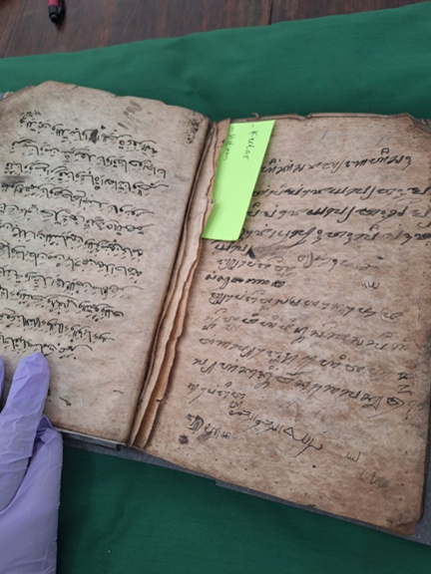
Figure 1 The Damaged Serat Pawukon Manuscript
It is challenging to pinpoint the manuscript's origin. This manuscript's language, spelling, and letterforms differ greatly from those often found in Central Java (Figure 2). Like most Balinese manuscripts, the text opens with the words "Om, awignam astu," but the language and the rajah it depicts also use a lot of Arabic words and characters. The long "a" vowel is used frequently in the manuscript, which is one aspect of its orthography. Given all of these factors, it may be presumed that this document was created in an area that is still inspired by Hindu and Balinese culture, but has also been impacted by Islam. It most likely came from Java's easternmost point, which may have been the Blambangan area. It is in accordance to Amelia, T. (2021) who stated that in ancient times, daluang was widely used as a medium for writing ancient manuscripts. In fact, for Hindus, daluang-based paper is sacred paper used in Ngaben situal processions, basic materials for tika, ketu, and others. Given how old the document is and the fact that daluang/dluwang was used, it is challenging to estimate its date.
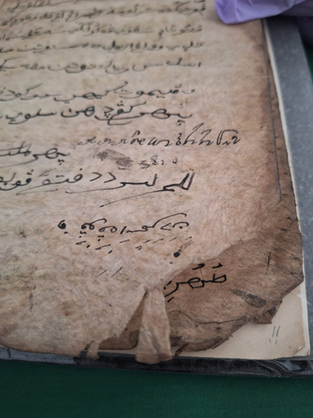
Figure 2 The text of Serat Pawukon Manuscript
Javanese Macapat material is included in Babad Tanah Jawi manuscript, which is written in Javanese (Figure 3). Because of its significant damage, its origin is impossible to ascertain. Its style and paper type are one potential hint. The text was copied before the 20th century, as evidenced by kertas telo type and the writing style, which are believed to have originated in Cirebon (Behrend, T.E., 1990). The condition is in a damaged look as shown in Figure 4.
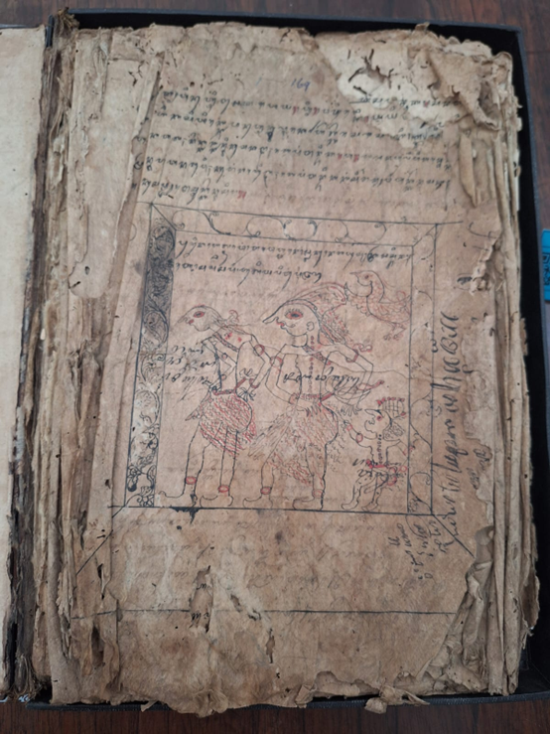
Figure 3 Javanese Macapat Text
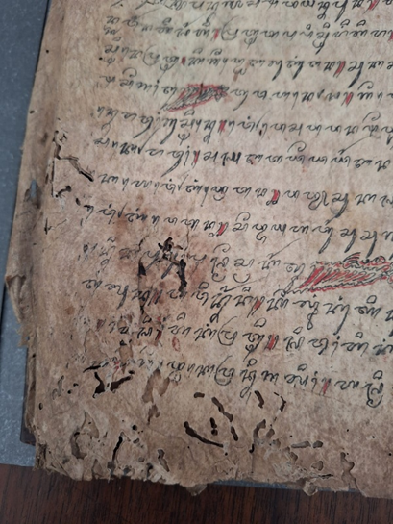
Figure 4 The damaged of Babad Tanah Jawi Manuscript
There are two sections to this work. Both the text and the writing are in Arabic (Figure 5). This manuscript is special, though, because it is bound in reverse from the remainder of the book. This section's content includes, among other things, prayers for the departed, for people who will be passing a grave, for the purpose to bathe before fasting, etc. (Behrend, T.E., 1990). The manuscript's second section, written in Javanese script (seen in Figure 6), includes the following texts: Excerpts from Unknown Fibers, Serat Sipatulwijra, Pepali Ki Ageng Sela Fragments, and Serat Wulang Reh Excerpts. According to the details on page 28 of this manuscript, Ki Ahmad Ngali, a native of Tepasanan (Surakarta), was the copyist. Despite being from Tepasanan, his writing style is similar to that of the North East coast. The letters are written similarly to Javanese scripts on palm leaves (lontar). The text appears to be quite old, possibly dating from the early 19th century, based on the writing style and the type of paper used, kertas telo.
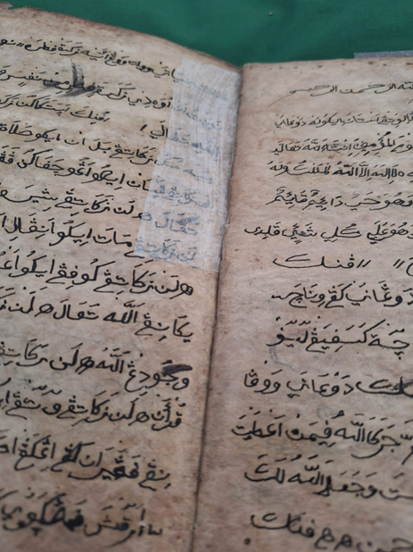
Figure 5 The Arabic Text of Serat Warni-Warni Manuscript
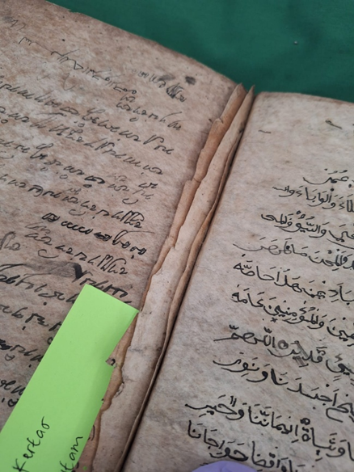
Figure 6 The Javanese and Arabic Text of Serat Warni-Warni Manuscript
The following features of the three manuscripts, the Serat Pawukon, the Babad Tanah Jawi, and the Serat Warni-Warni, represent the Sonobudoyo Museum's collection of manuscripts composed of kertas telo. They were identified, and have four characteristics: (1) the paper's surface is smoother and glossier than that of European paper; (2) the paper's material is less fibrous than that of European paper, which has a lot of fibre; and (4) the paper is more moist than other papers.
Table 1 Main Characteristics and Condition of the Manuscripts
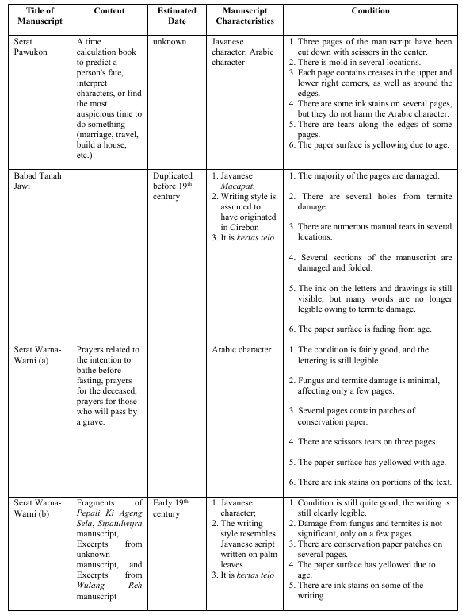
The three samples of the manuscripts which were composed of kertas telo undergo the preventive conservation processes. The following instruments were used to perform the procedures on manuscript collections composed of kertas telo: sponge, starch glue, and horsetail smooth brushes (Figure 7).

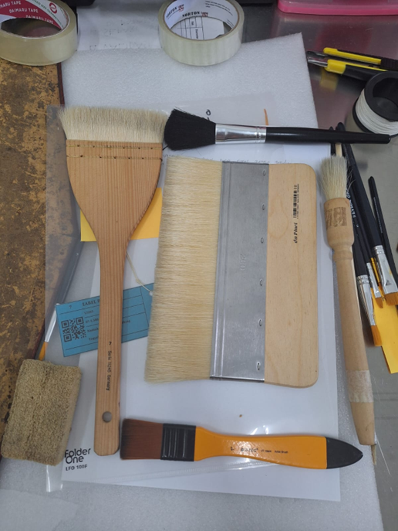
Figure 7 Tools for cleaning the manuscripts
The following is a preventive conservation method for kertas telo (daluang/dluwang): The first step is making the glue. For making the glue, there should be 3 grams of starch (WSP) and 30 ml of distilled water. To obtain a smooth glue, the cooked starch glue is filtered three times. It is shown in Figure 8 and Figure 9.
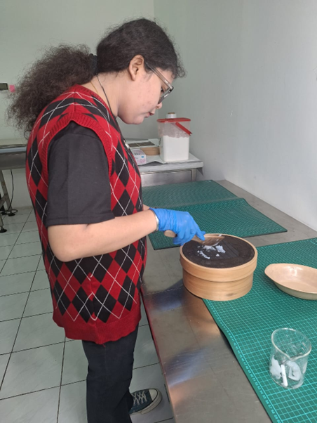
Figure 8 Preparing the starch glue
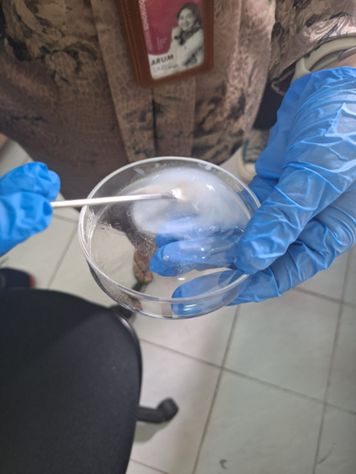
Figure 9 The starch glue after filtered three times
The second step is cleaning the surface of the manuscript from dust and dirt. This step is done by using a brush in an outward direction from both the front and back sides. It is shown in Figure 10 and Figure 11.
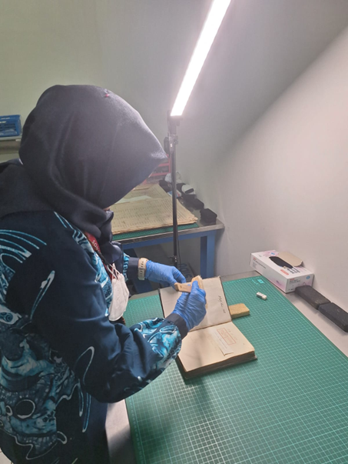
Figure 10 Brushing for both sides
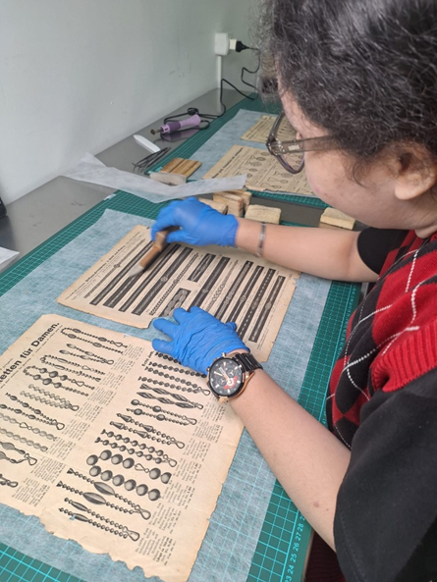
Figure 11 Cleaning the dirt and dust using horse’s tail brush
The third step is cleaning with a smoke sponge to further clean the paper surface. The procedure is needed as the smoke sponge is effective to move the dirt from the paper surface. It is shown in Figure 12.
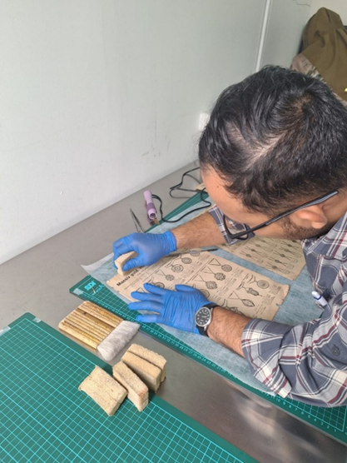
Figure 12 Cleaning the dirt and dust with smoke sponge
The fourth step is unfolding the paper which is found on the surface of paper. If there are folds on the sheet of paper, return them to the correct position using a ripper knife and an electric iron. It is shown in Figure 13 and Figure 14.
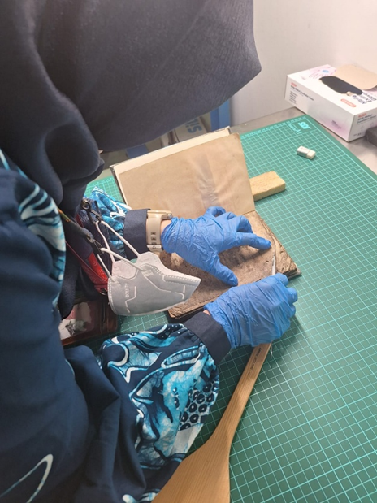
Figure 13 Unfolding paper with the ripper knife
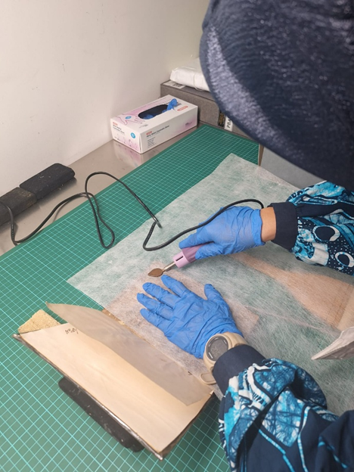
Figure 14 Ironing the folding paper with an electric iron
The fifth step is laminating the paper surface. The procedure is carried once the paper surface is already clean from the dirt. The paper surface is laminated with starch glue and covered with Japanese paper. They are shown in Figure 15a and Figure 15b.
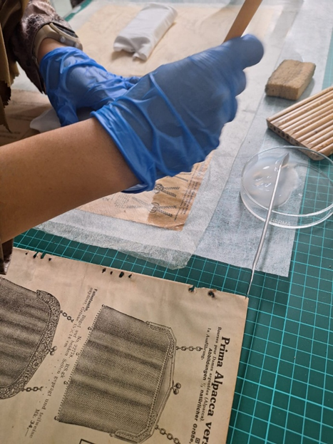
Figure 15a Laminating the surface with the starch glue
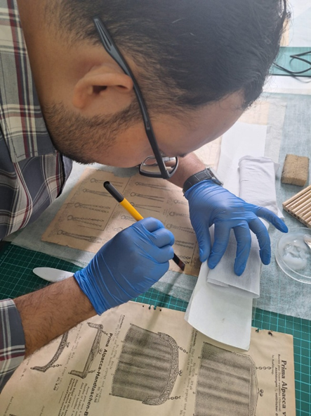
Figure 15b Laminating the surface with the starch glue
The sixth step is making the patch. The patch is made by tracing the paper and then applying aqua dest to the tracing line. Then, apply glue to the rough side of the paper. After applying the glue, stick it onto the torn paper. It is shown in Figure 16.
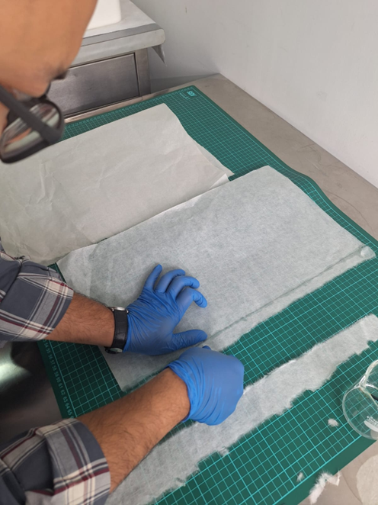
Figure 16 Making the patch
The seventh step is patching the damaged paper. After laminating, the paper is patched on the other side with 24 gsm Japanese paper and using aqua Dest, then torn by hand, without using scissors. They are shown in Figure 17a and Figure 17b.
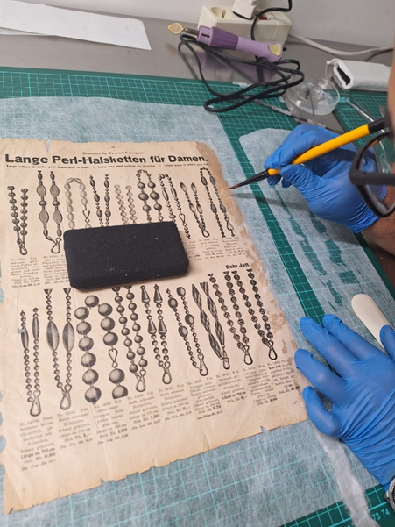
Figure 17a Patching the damaged paper
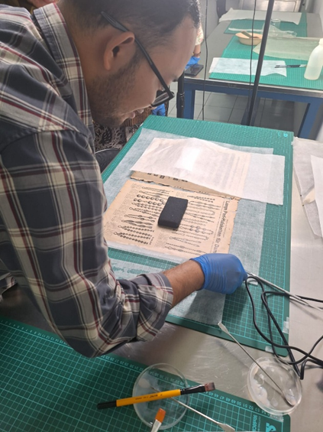
Figure 17b Patching the damaged paper
The eighth step is flattening the laminated paper. After laminating all sides, flatten them and use a weight to ensure the laminated paper surface sticks evenly. They are shown in Figure 18a and Figure 18b.
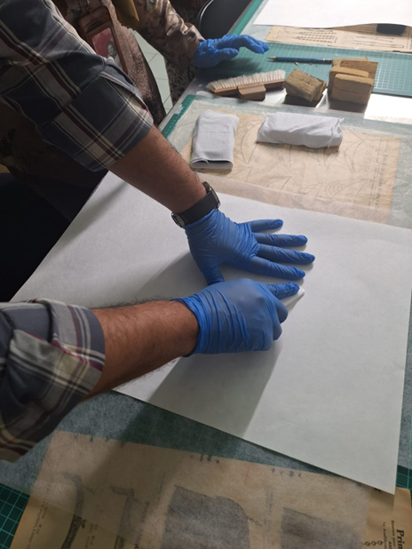
Figure 18a Flattening the laminated paper
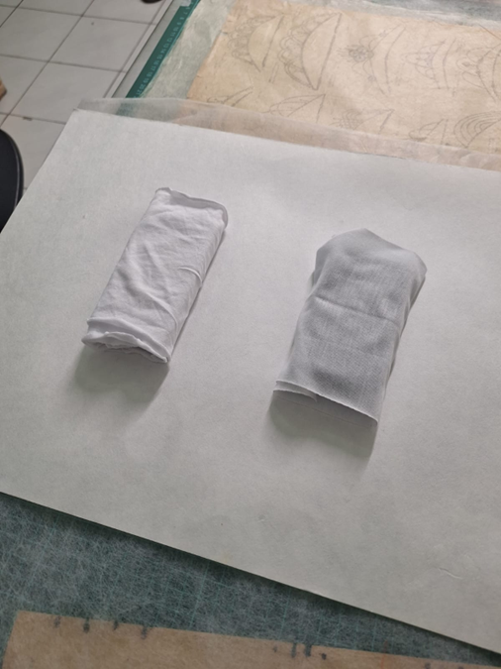
Figure 18b Flattening the laminated paper using a weight
The ninth step is pressing the laminated paper. After being laminated and flattened, the paper is ready to be pressed using a machine so that the glue surface is even and neat. It is shown in Figure 19.
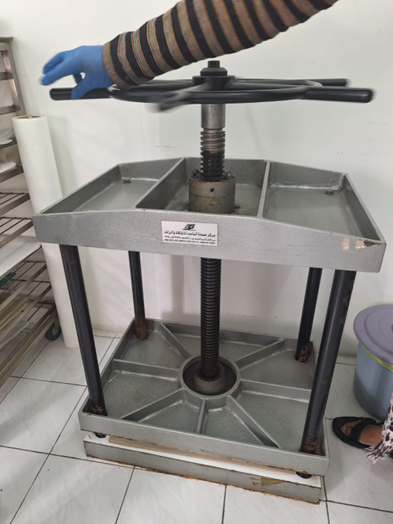
Figure 19 Pressing the laminated paper
The conservation methods employed for kertas telo manuscripts at the Sonobudoyo Museum are highly effective, as the collection necessitates regular care and rigorous control to minimize deterioration from humidity, insect infestation, and light exposure. Given the presence of approximately 3000 manuscripts in the museum, they are cleaned every five years in accordance with the Sonobudoyo Museum's preventive conservation standards for the manuscript collection. The insufficient number of conservators at the Sonobudoyo Museum poses a significant challenge to the adequate preservation of its collections. To mitigate this issue, the museum executes a fundamental routine maintenance program customized to the extent of deterioration of each item. Additionally, each manuscript undergoes a selective evaluation, leading to recommendations for ongoing care, encompassing both preventive conservation strategies and specialist restoration efforts. This approach reflects broader patterns observed at other Indonesian museums managing comparable manuscript collections, albeit with varying degrees of consistency in how those practices are implemented.
At the North Sumatra State Museum, preventive conservation combines routine environmental and biological control measures to counter the same tropical threats of pest infestation and fungal growth that affect manuscripts. Fumigation is used to eliminate pests and fungi, lemongrass oil is applied as a natural deterrent, and manuscripts are stored in shaded areas to limit exposure-related damage; this is further supplemented by gel-based chemical treatments and paper napkins for added physical protection. Importantly, these procedures are not left to guesswork in which the staff receive direct training from conservation experts, a structure aimed at ensuring consistency in how routine care is carried out (Nuraini, 2024).
A comparable case is documented at Museum Ranggawarsita's library collection in Semarang, where researchers examined the specific factors contributing to manuscript damage alongside the preservation procedures employed to counter them. That study placed particular emphasis on evaluating the gap between conservation theory and its actual application in the field, finding that practical execution did not always align cleanly with documented preservation standards (Khafidlin, 2021). This suggests that even where preservation protocols exist on paper, their real-world consistency depends heavily on staff capacity and institutional follow-through.
Set against these cases, the Sonobudoyo Museum's routine maintenance program which is structured around item, specific deterioration assessments and selective evaluation, represents a comparably systematic model of preventive conservation, similarly reliant on trained staff and standardized procedures to counter the same tropical environmental pressures documented at North Sumatra State Museum and Ranggawarsita Museum. From this regular care, there should be recommendations for further treatment, encompassing both preventive conservation strategies and specialist restoration efforts where deterioration has progressed further. This approach enables the Sonobudoyo Museum to preserve the quality and sustainability of kertas telo manuscripts, considering an inadequate number of conservators in which a constraint echoing the staffing challenges documented across other Indonesian museum collections (Nuraini, 2024), and one that, consistent with the Ranggawarsita case, may be one contributing factor in how reliably theoretical preservation standards are translated into practice.

CONCLUSION

The three of seven manuscripts collection of the Sonobudoyo Museum were investigated to understand the history of using kertas telo, known as daluang/dluwang, as well the study of manucripts collection of Sonobudoyo Museum made of kertas telo/daluang. Moreover, the study also resulted the preservation procedure of kertas telo/daluang as an alternative writing medium to replace European paper in the early 20th century. The preventive conservation procedures were implemented on the three manuscript samples that were composed of kertas telo/daluang. The method of preventive conservation consisted of nine procedures following the standardized procedure for manuscript conservation. The Sonobudoyo Museum's conservation methods for kertas telo/daluang manuscripts are highly effective, as the collection requires regular care and rigorous control to prevent deterioration from humidity, insect infestation, and light exposure caused by tropical environmental conditions. As a result, the museum with such manuscript collections requires preventive conservation methods such as stable storage conditions, proper handling, regular monitoring, and pest control to help preserve these fragile artifacts.
The study emphasizes the significance of developing conservation knowledge and abilities for manuscript materials such as kertas telo/dluwang. However, this study has a few shortcomings. It only includes observations of specific manuscript collections, conservation procedures, and recommendations for manuscript conservation. The study excludes long-term scientific testing, laboratory-based material analysis, and conservation treatments for a large number of manuscripts. Despite these limitations, the study stresses the need of preserving kertas telo/dluwang manuscripts as part of Indonesia's cultural heritage, particularly in tropical areas where environmental conditions can speed up deterioration.
In order to prevent further damage from the tropical climate and to preserve the preservation of objects for future generations, the research produced recommendations for appropriate preventive conservation, a condition report of samples of the kertas telo archive collection, and an analysis of conservation efforts carried out by the museum. In addition, further recommendation to regular basis for each collection treatment based on the damage condition is strongly supported. Furthermore, disparities in storage facilities, environmental conditions, finance, and personnel expertise among Indonesian museums may have an impact on the practical implementation of these guidelines. It is therefore, museums, scholars, and government organizations continue to play a vital role in strengthening long-term conservation initiatives.
ACKNOWLEDGEMENT

The authors gratefully acknowledge the Lembaga Penelitian dan Pengabdian Masyarakat (LPPM), Institut Seni Indonesia Yogyakarta, for the funding support that made this research possible. The authors also thank the reviewers for their valuable feedback and constructive comments, which significantly improved the quality of this manuscript.

REFERENCES

Ahmad, M., & Wilkins, S. (2025). Purposive sampling in qualitative research: a framework for the entire journey. Quality and Quantity, 59(2), 1461-1479. Article e24115. https://doi.org/10.1007/s11135-024-02022-5
Amelia, T. (2021). Daluang, si kain kulit kayu yang langka. In Etnik: Pesona kain khas Nusantara. Rumah Media.
Behrend, T. E. (1990). Katalog induk naskah-naskah Nusantara: Jilid 1 Museum Sonobudoyo Yogyakarta. Djambatan.
Engel, P., Maharsi, I., Hapsari, P. D., Warsono, & Wulandari, W. S. (2022). Wayang Beber preservation: Towards an Indonesian conservation theory. Conservation Update, 1, 35–79. https://doi.org/10.48341/5hkw-8c67
Hidayat, Wahyu., et.al. (2025). Preserving Bark Cloth as Local Culture Through Traditional Schools in Rampi District. Proceedings of The 5th International Conference on Linguistics and Cultural Studies 5 (ICLC-5 2024). https://doi.org/10.2991/978-2-38476-394-8_47
Indriani, S.D., et.al. (2022). Konservasi Preventif Untuk Mencegah Kerusakan Koleksi pada Museum Geologi Bandung. Jurnal Perpustakaan, 13(2), 119-125. https://doi.org/10.20885/unilib.Vol13.iss2.art7
Irshad, M. & Chaudhry, A. G. (2023). Principle nature of ethnography: A systematic literature review of qualitative research method in anthropology. Pakistan Journal of Social Research, 5(4), 1–9. https://pjsr.com.pk/ojs/index.php/PJSR/article/view/1326
Kaharuddin, K. (2020). Kualitatif: Ciri dan karakter sebagai metodologi. Equilibrium: Jurnal Pendidikan, 9(1), 1–8. https://journal.unismuh.ac.id/index.php/equilibrium/article/view/4489
Khafidlin, K. (2021). Ancient manuscript preservation of Museum Ranggawarsita Library Collection Semarang Central Java. Daluang: Journal of Library and Information Science, 1(1), 52–58. https://doi.org/10.21580/daluang.v1i1.2021.8001
Lennard, F., & Mills, A. (2020). Material approaches to Polynesian barkcloth: Cloth, collections, communities. Sidestone Press.
Liu, Y., Huang, J., Ou, M., Ding, H., Ma, Y., & Zhuo, L. (2025). Characterization of a novel cellulosic fiber from Broussonetia papyrifera L. bark for green-epoxy composite: Effect of fiber treatment. International Journal of Biological Macromolecules. https://doi.org/10.1016/j.ijbiomac.144020
Markova, V. A. (2021). Book communications: Methodology of interdisciplinary research. Scientific and Technical Libraries, 11(3), 95–112. https://ntb.gpntb.ru/jour/article/view/748
Masriani, R. (2025). Karakteristik Daluang Atau Paper-Mulberry, Bahan Pembuatan Naskah Kuno Untuk Pembuatan Kertas Arsip Masa Kini. Prosiding Seminar Nasional Industri Kerajinan Dan Batik, 6(1), A.05 1-22. Retrieved from https://proceeding.batik.go.id/index.php/SNBK/article/view/271
Nurahma, G. A., & Hendriani, W. (2021). Tinjauan sistematis studi kasus dalam penelitian kualitatif. Mediapsi, 7(2), 119–129. https://doi.org/10.21776/ub.mps.2021.007.02.4
Nuraini, N. (2024). Assessing ancient manuscript conservation practices: A case study on local content preservation at the North Sumatra State Museum. Multidisciplinary Science Journal, 7(1), Article 2025008. https://doi.org/10.31893/multiscience.2025008
Octina, R. L., et.al. (2025). Preservation strategies for photographic collections in tropical climates: Evaluating practices at Sonobudoyo Museum. Environment-Behaviour Proceedings Journal (E-BPJ), 10(SI39), 197–203. https://doi.org/10.21834/e-bpj.v10iSI39.7692
Ortiz, L., & Jiménez de Madariaga, C. (2022). The UNESCO convention for the safeguarding of the intangible cultural heritage: A critical analysis. International Journal of Cultural Policy, 28(3), 1–19. https://doi.org/10.1080/10286632.2021.1969523
Perdoch, W., et al. (2022). Influence of nanocellulose structure on paper reinforcement. Molecules, 27(15), 4696. https://doi.org/10.3390/molecules27154696
Permadi, T., Guzzini, A., & Kurniasih, E. (2025). Sacred paper: Exploring the materiality and symbolism of daluang in Balinese Hindu rituals. Jurnal Kajian Bali, 15(2), 443–471. https://doi.org/10.24843/JKB.2025.v15.i02.p01
Purwanto, D. (2021). Informan dan pemilihan informan pada penelitian kualitatif [Unpublished manuscript]. https://www.researchgate.net/publication/353840858
Putri, M., & Poeni, S. (2020). Perbandingan kandungan selulosa dan lignin dari kayu Acacia crassicarpa dan Acacia mangium. REACTOR: Journal of Research on Chemistry and Engineering, 1(1), 12. https://doi.org/10.52759/reactor.v1i1.3
Rachman, Y. B., Salim, T. A., Rachman, M. A., & Ratnasari, W. (2022). Dluwang manuscripts from Royal Surakarta, Indonesia: Deterioration phenomena and care practices. Studies in Conservation, 67(5), 289–301. https://doi.org/10.1080/00393630.20 21.1923284
Rahmawati, F., Basuki, R., Fahri, M., Apriliyanto, Y. B., Kurniadi, T., Nareswari, V. A., Sandri, A., & Istiqomah, T. (2024). Reaction mechanism in standardized α-cellulose content test: Study from Boehmeria nivea fiber. Indonesian Journal of Chemical Studies, 3(1), 22–27. https://doi.org/10.55749/ijcs.v3i1.45
Reid, A. (2014). Asia Tenggara dalam kurun niaga 1450–1680 jilid 1: Tanah di bawah angin. Yayasan Pustaka Obor Indonesia.
Riski, M. A., & Irpina, W. (2025). Strategi pelestarian warisan budaya di era 4.0: Studi pada koleksi langka perpustakaan dan Museum Sonobudoyo Yogyakarta. Nazharat: Jurnal Kebudayaan, 31(1). https://nazharat.fah.uinjambi.ac.id/index.php/nazharat/article/view/108
Salim, T. A., Azmir, A.F., Sani, M.K.J.A. (2025). Research analysis on the physical preservation of Daluang and European paper manuscripts in the Scopus database. Jurnal Kajian Informasi & Perpustakaan, 13 (2), 285-302. https://doi.org/10.24198/jkip.v13i2.67396
Soukup, M. (2025). Cultural memory on tapa: Bark cloth from the Uruwa Valley of Papua New Guinea. Cultural Studies / Kulturní Studia, 25(2), 64–82. https://doi.org/10.7160/KS.2025-02(25).04
Suranto, C. A., Sudiono, S., & Ekarini, F. D. (2024). Development of thin conservation-grade paper from Indonesian paper mulberry (daluang). Jurnal Konservasi Cagar Budaya, 18(2).
Tajik, M., et al. (2024). Purposive sampling. International Journal of English Language Studies (IJELS), 2(2). https://doi.org/10.22034/ijels.2025.490681.1029
Taufan, M., Nurafifah, L., & Gading, G. (2025). Etnomatematika dalam proses pembuatan kertas daluang di Kabupaten Indramayu. Indo-MathEdu Intellectuals Journal, 6(2). https://doi.org/10.54373/imeij.v6i2.2870
Teijgeler, R. (2016). Dluwang: Cultural-historical aspects and material characteristics [Research report]. (Original work published 1995)
Wahyu, I. C. D. K., et al. (2020). Dluwang Ponorogo narrative as enrichment of materials in historical learning based on local wisdom. Social, Humanities, and Education Studies (SHEs): Conference Series, 160–168. https://jurnal.uns.ac.id/shes
Yahya, F., & Jones, R. (2021). Special issue: Malay manuscripts—A guide to paper and watermarks. Indonesia and the Malay World, 49(144), 139–394. https://doi.org/10.1080/13639811.2021.1939521

